**Project Management**

**Summary:**

Agile process is the software development method we have used. We have divided the project plan into four increments where each increment included improvements in both back end and front end implementation from increment to increment. Besides this we used stories for video presentation and Final Package Submission also. We have used ScrumDo for our project management and for maintaining the project artifacts. Our team consists of four members’ and the project development has been shared equally between all of us. In each phase two members used to work on back end and two members used to work on front end. And these will be swapped in successive increments. Finally all the team members passed through all the stages of the project life cycle from design to the UI testing.

The below are the tasks that have been scheduled in each of the increments:

If there are any pending backlogs we all worked together to nullify them.

**Iteration-0:**

1. Construction of workflow diagrams. - Ravisha
2. Combination of features to be implemented in application. - Suresh
3. Observation of Data sets and API’S useful for the application. - Sarath
4. Study of Project goals and objectives. - Siva Krishna
5. Investigation of system architecture. - All

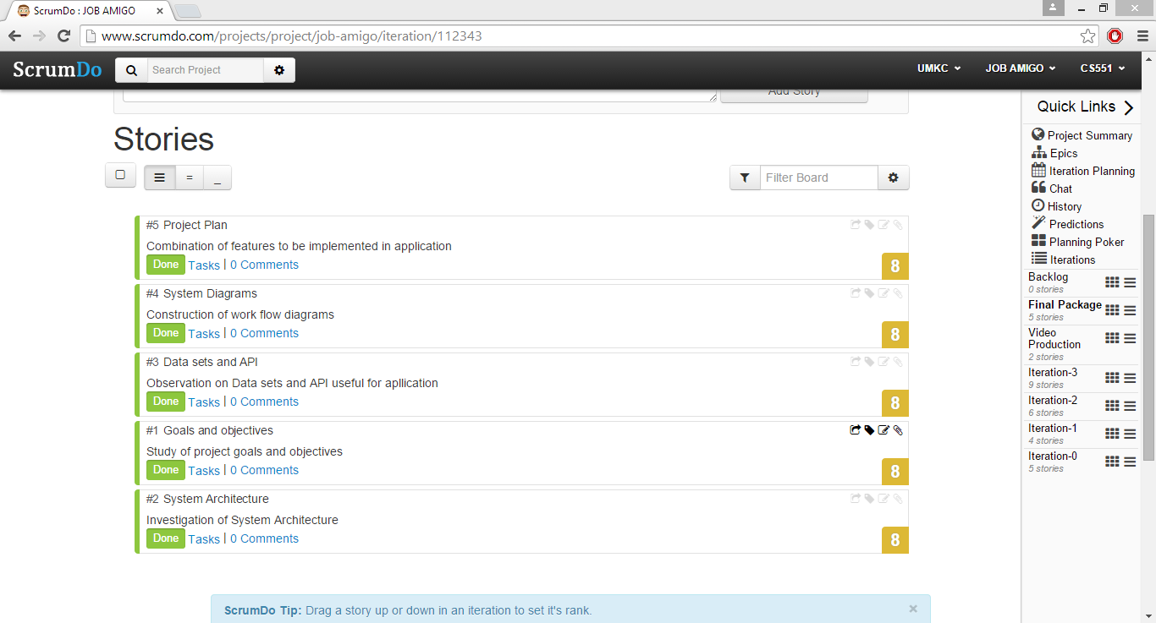

**First Increment:**

1. Design of login screen for users. - Ravisha
2. Construction of Database Schema for application. - Sarath
3. Analyzing and implementing the functional requirements. – Siva Krishna
4. Collecting and extracting required data. - Suresh

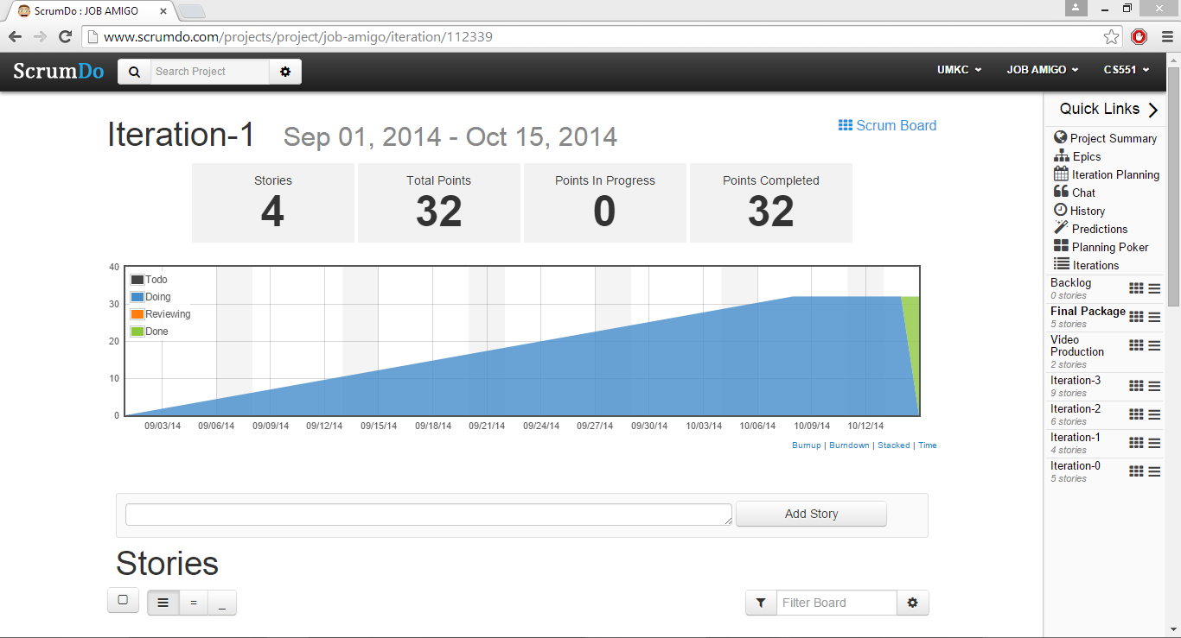

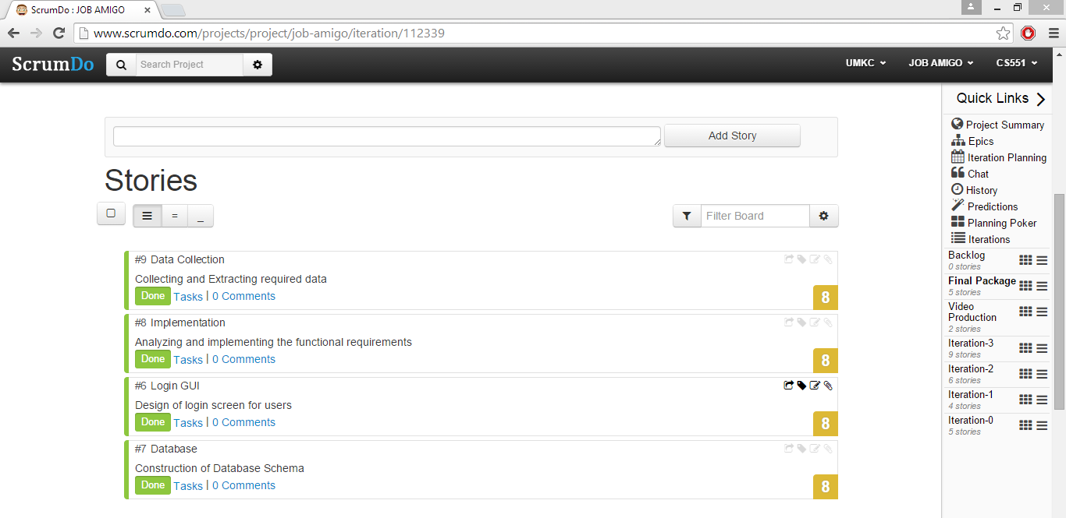

**Second Increment:**

1. Completing the entire GUI design with certain animations. - Suresh
2. Linkage of data with database and retrieval. – Siva Krishna
3. Testing and extracting required data. - Ravisha
4. Data analyzing and filtering using search criteria. -Sarath
5. Usage and creation of the services for the required functionalities. – Siva Krishna & Sarath
6. Storing the required data and displaying it to the user when required. – Suresh & Ravisha

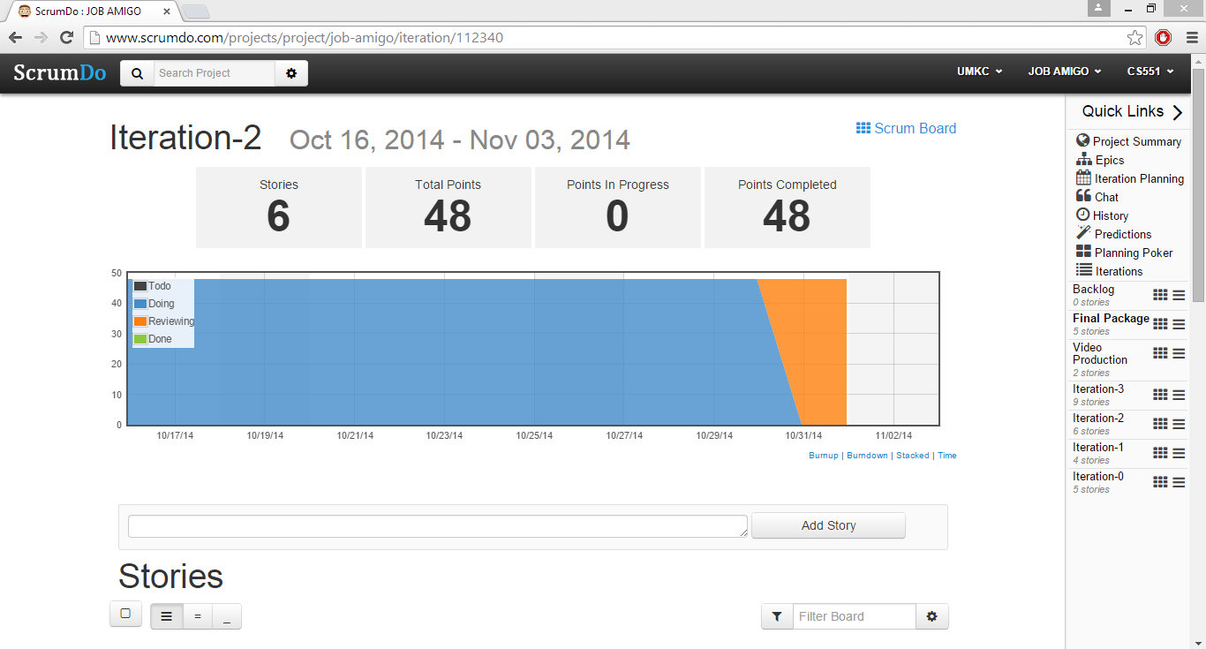

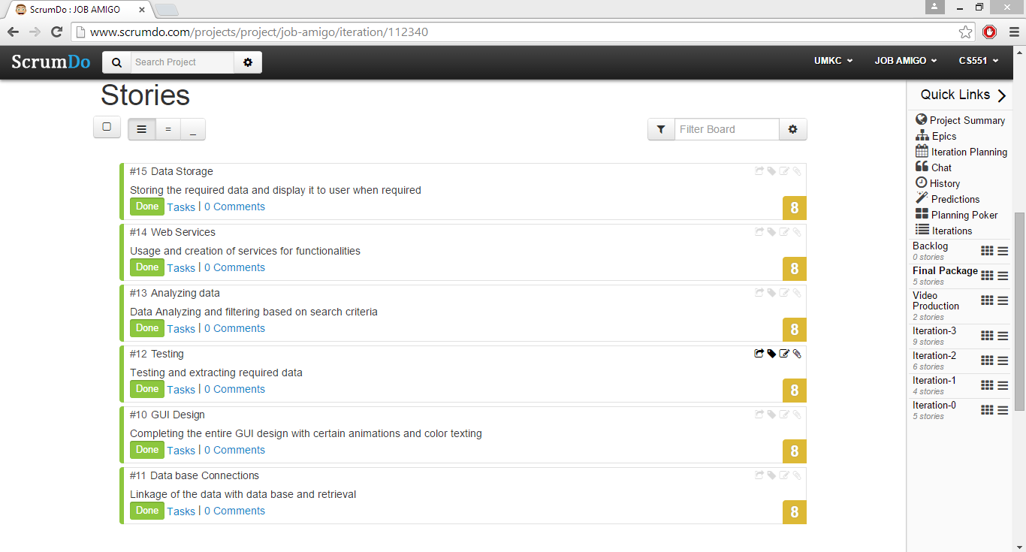

**Third Increment:**

1. Apply to jobs online from the available description of the job based on criteria. - Sarath
2. Alerting the user such as alert messages and mail alerts. – Siva Krishna
3. Text to speech conversion for the required page transitions. – Siva Krishna & Ravisha
4. Usage of open source API’S like Google and Weather services etc… - Suresh & Sarath
5. QR code and Instagram implementations to improve the security and sharing. - Ravisha
6. Implementation and usage of API’S for easy accessibility for jobs. - Sarath
7. Services for the login and registration. – Siva Krishna
8. Resume Services for addition and deletion in application. - Ravisha & Sarath
9. Testing the entire application.- All

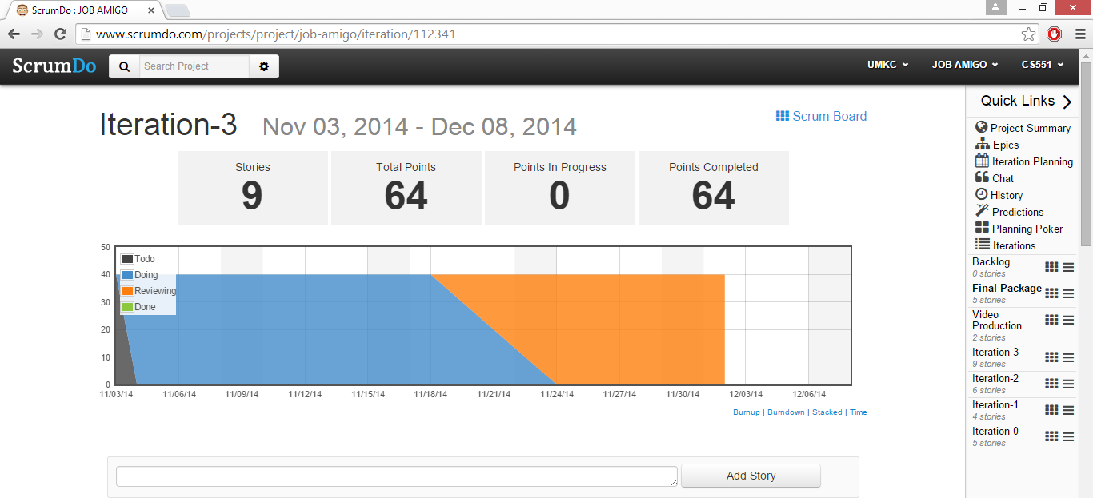

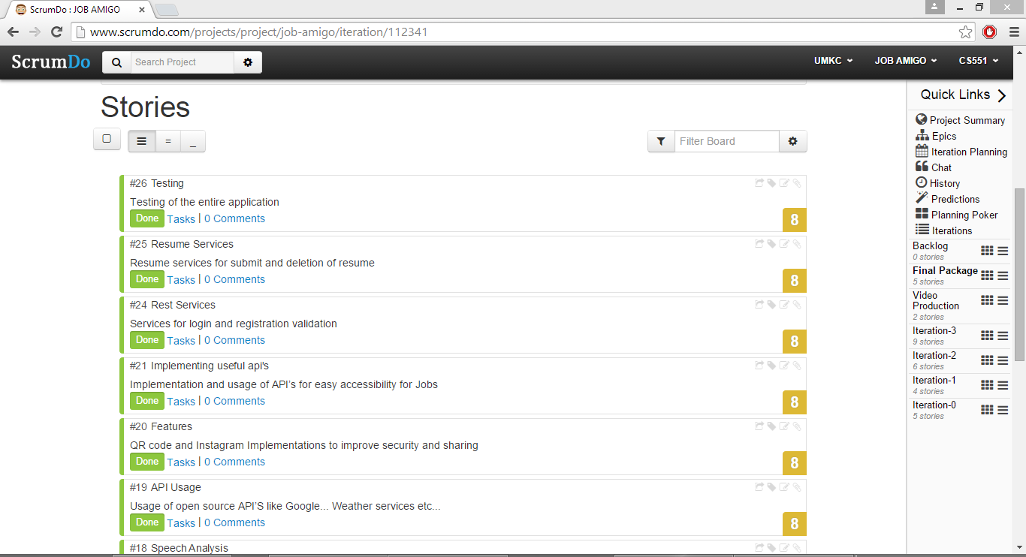

**Video Production:**

1. Study of useful software’s for video production. - All
2. Preparing the script for the video recorded. - All

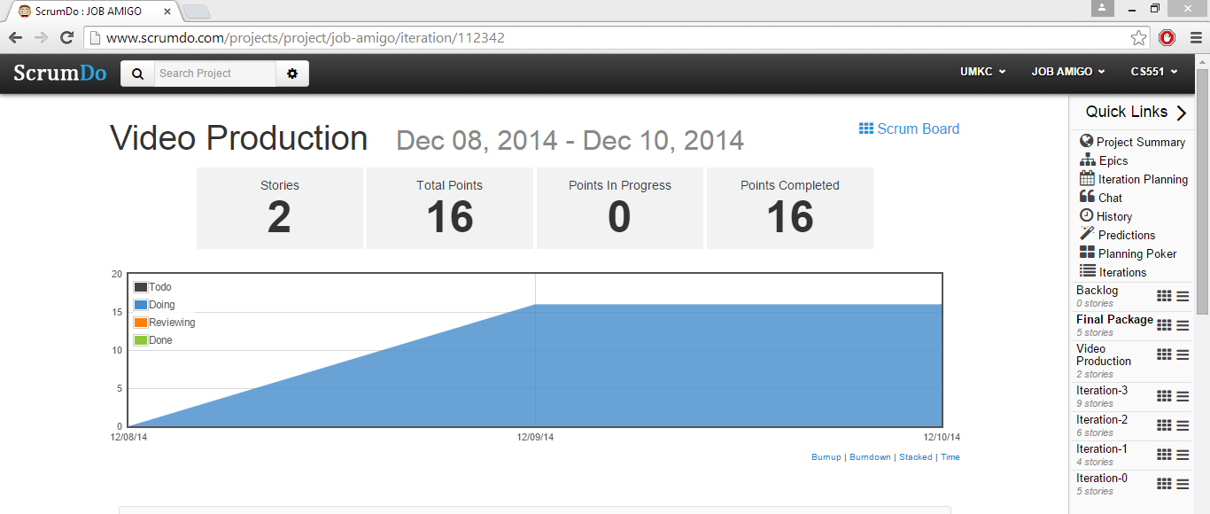

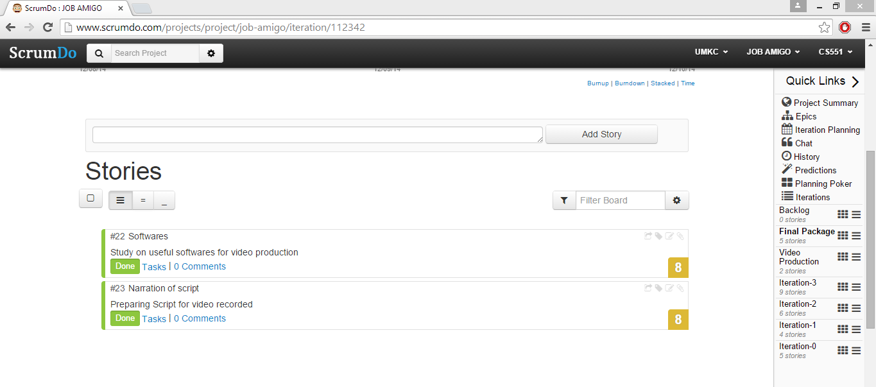

**Final Submission:**

1. Collecting and modifying the changes to the challenge documents. - Sarath
2. User manual and project deployment documents. – Siva Krishna
3. Presentation material and others.- Ravisha
4. Collection of documents and sorting them out for printing. - Suresh
5. Final peer reviews and submission. - All

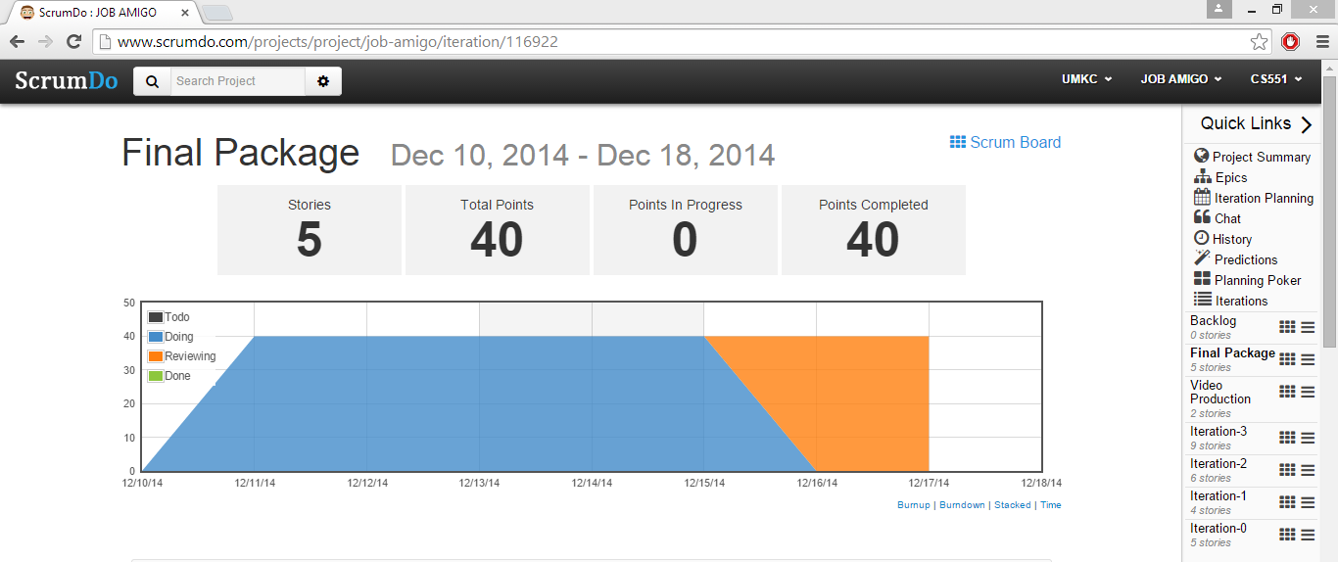

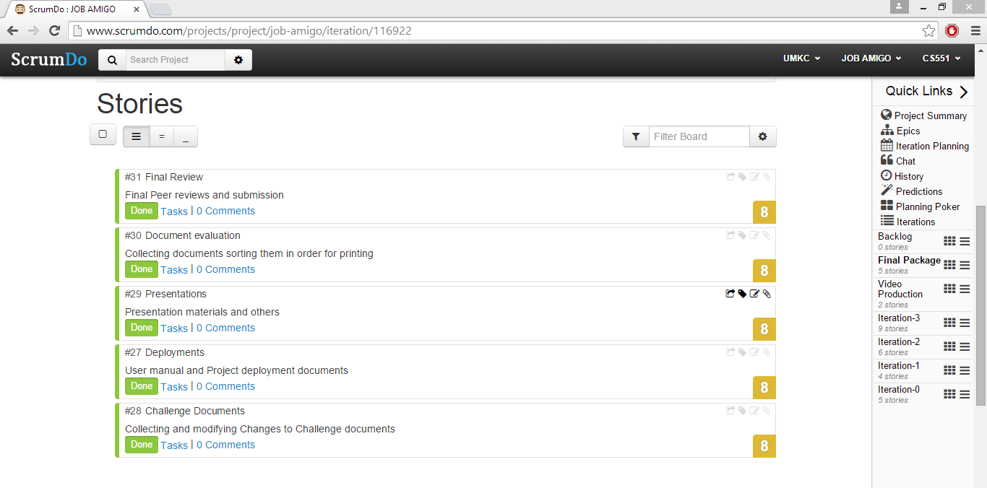

**Project Summary:**

The entire project summary is shown below with a graph, which reflects the process in project development in each iteration:

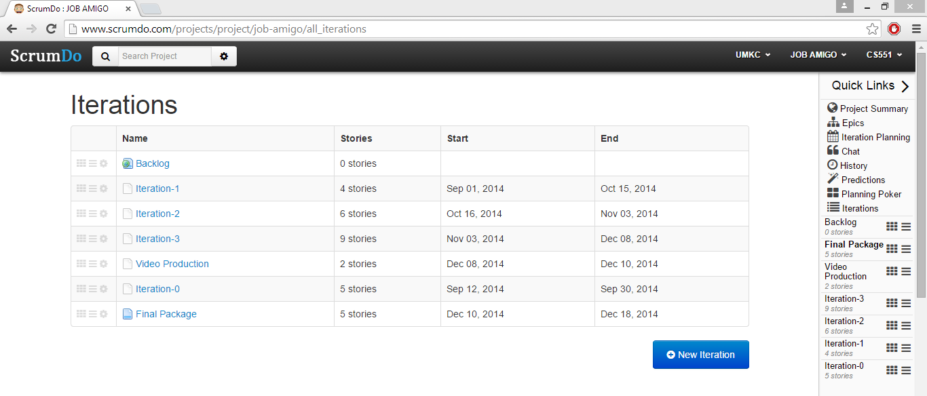

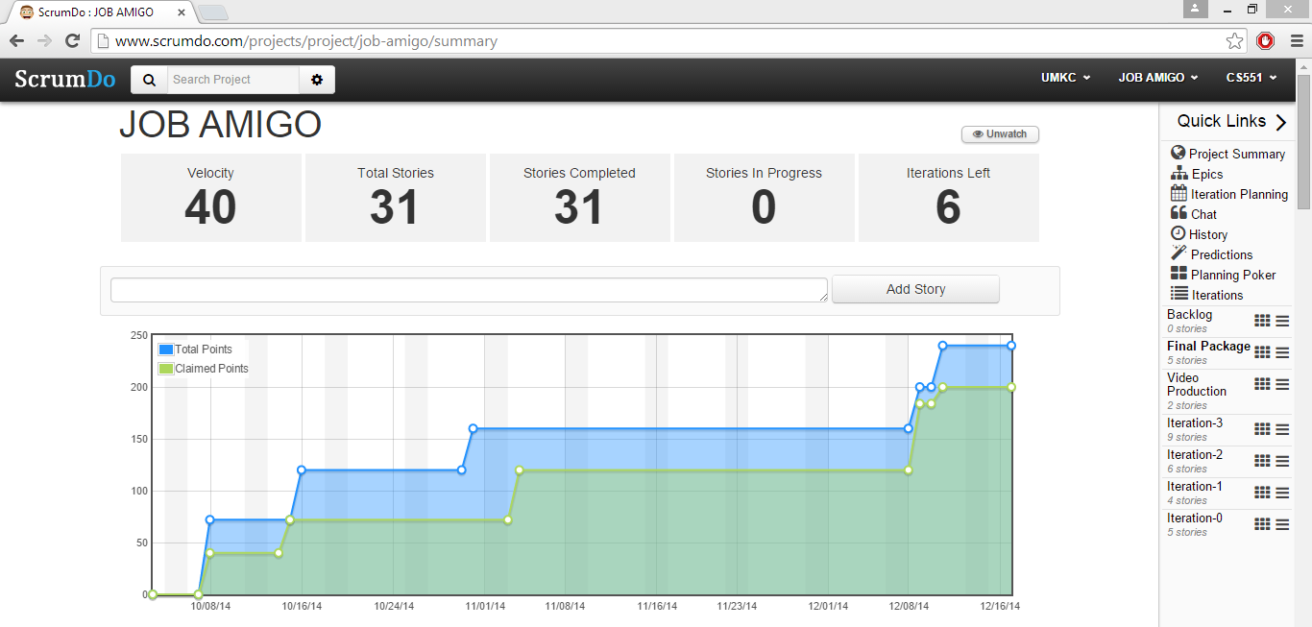

The entire project scrum work and tasks can be viewed in the following link:

* <http://www.scrumdo.com/projects/project/job-amigo/summary>